Manorowen

SM935364 OS 25” 2nd edition IX.2 & 3 Manorowen, Fishguard

Cadw listed walled garden and (separately) gazebo

Cadw Register of Historic Parks and Gardens

7th January 1998
Mr rogers has now cleared the ivy from the inside and from the tops of the garden walls and repaired some of them. There is some recent storm damage to the large entrance gate and piers in the west wall. The collapsed part of the lower wall awaits rebuilding. There is evidence that the lower end of the west wall was, at one time, only about 1.7m high. The high wall at the NE corner is built of more substantial stone.

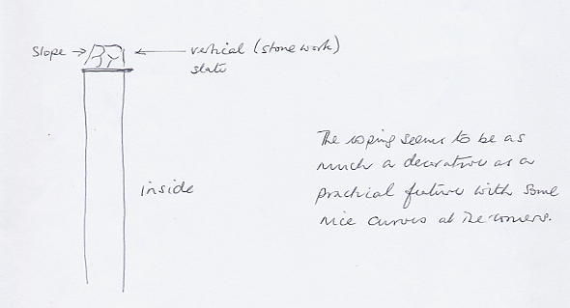

The internal walling – viewpoint, terracing, backing of the glasshouse – is of a different construction (and date?). The glasshouse wall has evidence of a fireplace at the right hand side from which two horizontal and parallel flues go left with a vertical flue at the left end.
(from notes made at the time)

Documents infile:
Text (minimal)
Listing of walled garden
Listing of gazebo
Notes about walls and glasshouse flue.
B/W photograph of mansion (NLW)
Colour photographs of garden, gazebo, walls etc
Colour photographs of church memorials
Church leaflet
Colour slide of gazebo in tapestry
Completed WHGT form
Sketch plan of walled garden
Leaflets for visitors (2)
Sale Advertisement in Western Telegraph April 2006

