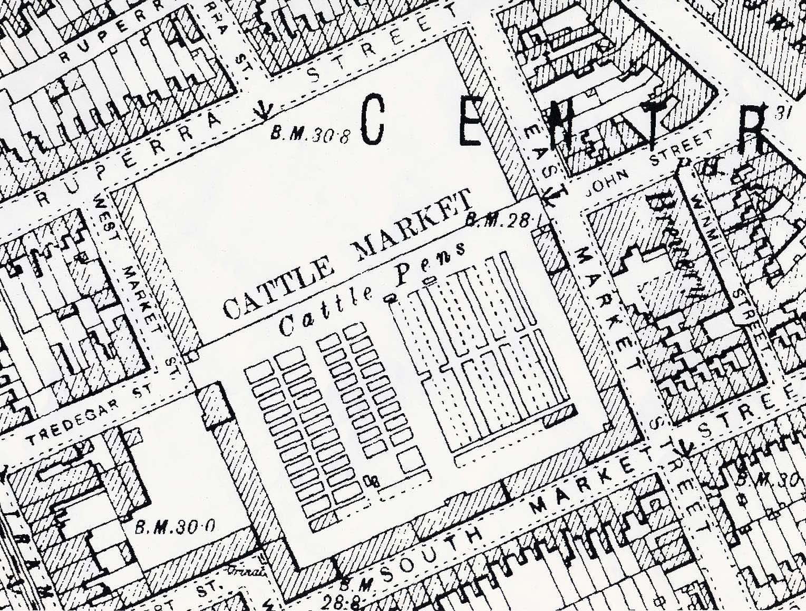
Project:

Newport Cattle Market
Title:
Ordnance Survey Map
 |  |  | Scale:  Not to scale | Date:  11/01/05
NGR:
ST 314 873
Illustration No.:
019

