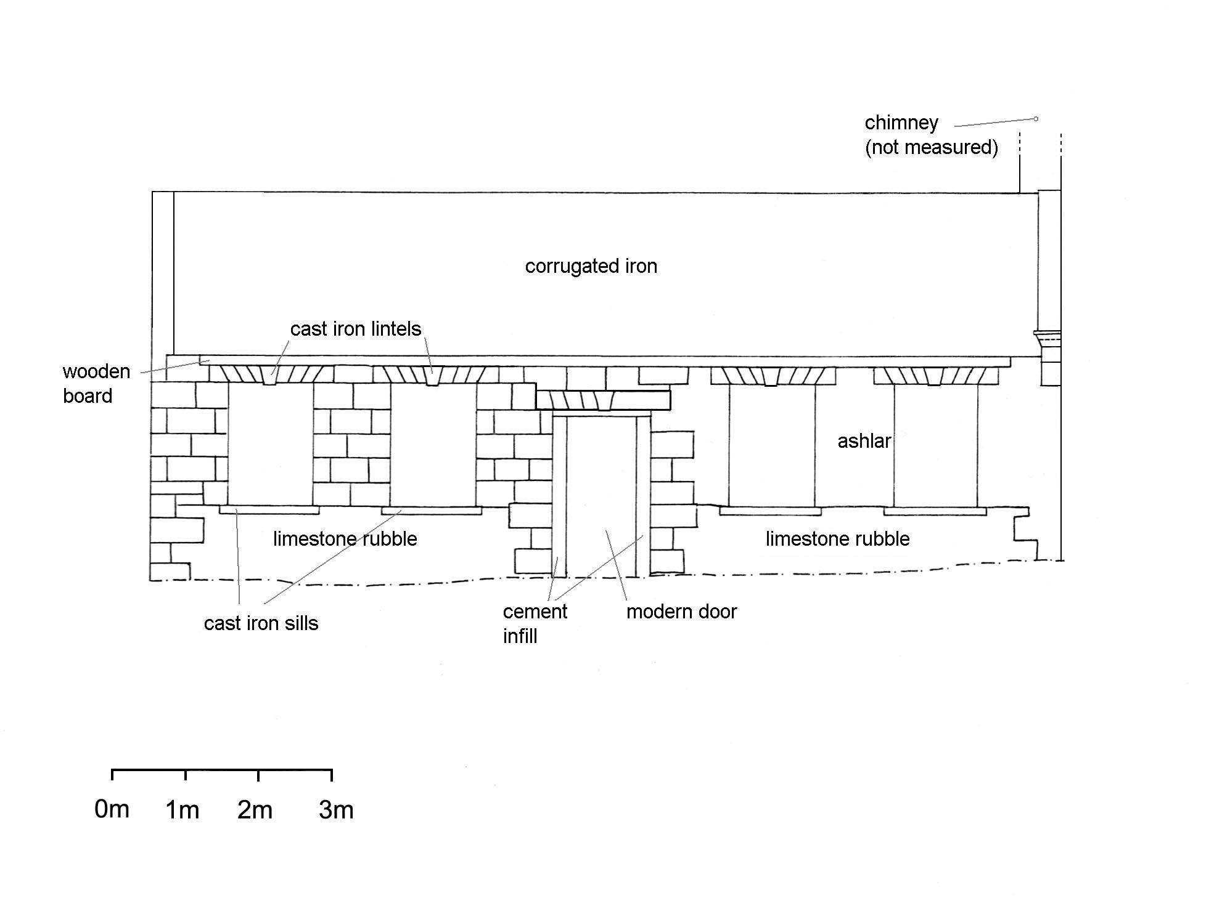
Project:
Newport Cattle Market
Title:
East Elevation of Managers Cottage

Scale:  1:100 | Date:  16/09/04
NGR:
ST 314 873
Copyright:  Ironbridge  Institute | Illust. No.:  007

