CONSERVATION REPORT DATE: 27.3.08
RESTORER: H. Dowding
THIS REPORT IS AN UPDATE OF REPORT MADE 5.3.96 BY R. HOWELLS
LOCATION/OWNER: National Trust, Dynevor Castle
MUSEUM NO: TH/P/35L
TITLE/ARTIST: Old Dynevor Castle/Unknown
DIMENSIONS: 873mm (h) x 1257mm (w) x 23(d)mm
FRAME DIMENSIONS: unframed for examination
INSCRIPTIONS: As 1996 report
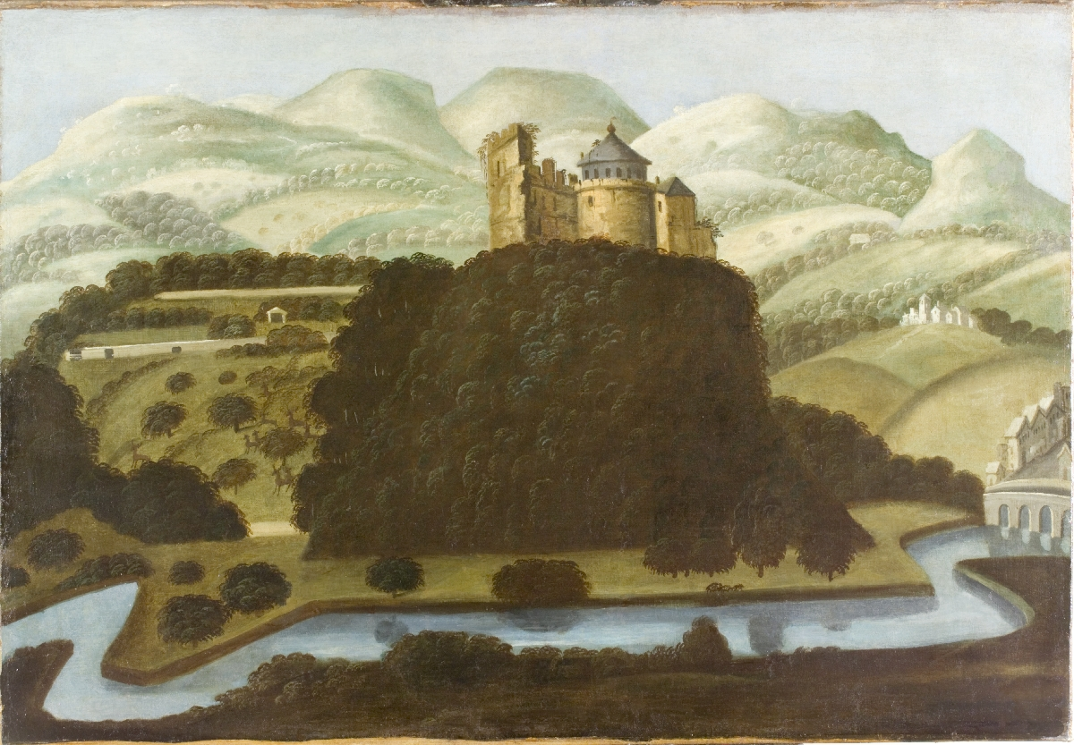

FRAME: Black painted wood display frame
FITTINGS: Brass mirror plates
GLAZED: 4.4mm laminated low reflective glass
BACKBOARD: Melinex backing with gummed paper tape dust seal
CONDITION: Fair condition, fairly rigid, a few small knocks and scrapes to the black painted coating

SUPPORT:
CANVAS: The original canvas has been lined and the tacking edges removed so examination of the original was not possible. However, the original canvas weave can be seen on the x-ray, and at the top edge of the top RHC of the painting, to have been medium/coarse plain weave. Only slight cusping could be seen at all four edges, this may indicate that the canvas has been reduced in size.

X-radiograph
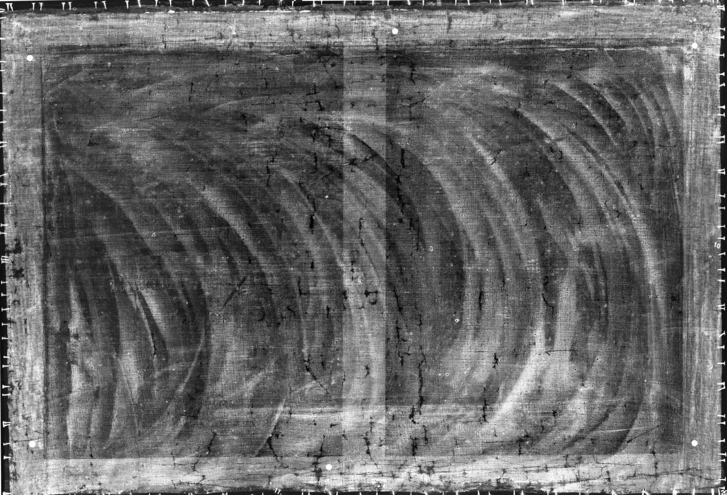

The x-radiograph shows up paint losses in the original paint and ground as dark patches scattered over the surface, but mainly visible at the edges and along the bottom. Otherwise, any further detail in the x-radiograph is masked by the strong absorption of the ground with the broad pattern of arc-shaped scrapes relating to the application of the priming. See PRIMING below. Close observation of the x-radiograph revealed a suggestion of a figure with a raised arm in the centre of the painting just behind the central cross bar. This figure would be out of proportion to the landscape and may have been on the canvas before the current painting was begun, possibly a sketch for another painting.

STRETCHER: Five membered softwood stretcher, probably nineteenth
century that may have replaced the earlier stretcher when
the canvas was lined. The lining canvas was stuck to the
back of the stretcher.
WEDGES: Key for top left (from back) is missing, as it was in 1996. All the keys present are secured with fishing wire and screws.
LINED: Yes – probably glue-paste (rather than wax, as supposed in 1996). Unframed examination revealed some adhesive around the edges of the original canvas. The lined canvas is very stiff and rigid.
ATTACHMENT TO STRETCHER: Rusty iron tacks, evenly spaced, on the sides. Lining canvas has been stuck to the back of the stretcher.
SLACK: No, the tension is good.
HOLES: None apparent.
TEARS: All corners are slightly torn, but this is not affecting the canvas tension at present. Reinforcement of the canvas in these areas would be advisable to prevent further deterioration of the turnover edge and loss of tension at the corners.
DENTS/BULGES: None apparent.
WOODWORM: None apparent.
CONDITION: Holes from old fittings, and gouges, in the stretcher. Lining adherence appears good.

PRIMING
A layer of grey priming appears to lie directly on the sized canvas. This appeared to consist of two layers, a lower white layer and a second grey layer containing white and black pigments, though the ground was so soft and crumbly it was not possible to take a good cross section of all the layers to confirm this. See report by Libby Sheldon that includes photographs of some of the cross sections taken. In the photographs of the cross sections, the top layer of ground with small black pigments can be seen, but the lower layer is missing. This type of ground seems quite common for the time, Kate Stonor has noted this in the seventeenth century works at the Courtauld Gallery, London and Tate Gallery, London, see Appendix 1. Arc shaped streaks visible in the x-radiograph appear to relate to the application of the first priming layer with a palette knife. She found that the first layer would consist mainly of a chalk rich oil layer, then a thinner grey priming composed of lead white and charcoal black, in TH/P/38L, Libby thought the black was likely to be lamp black. The thin lead white rich second layer would be caught in the grooves left by the palette knife in the lower layer giving rise to the x-ray dense lines. The same pigments may be present in the lower ground on this painting but have not been confirmed by analysis.

PAINT FILM: Probably oil (not tested).
The paint film appears to have been applied in one or two thin layers. The sky and landscape including the trees appear to have been applied directly over the ground with highlights of the trees applied on top. The trees appear formulaic, the highlights of the distant trees have probably been applied with a specially made arc shaped brush. The deer on the centre LHS are also formulaic and are similar, though slightly cruder than those of ‘Llanerch’ Anon, Denbighshire c. 1662, 1142 x 1517mm (Peter Lord, ‘Imaging the Nation’ 2000, p. 80).

Examination by x-radiography, infra red and visual examination under the microscope showed no major changes. The sky appeared to be a mixture of lead white and smalt. The x-radiograph of this painting shows the sky to be less x-ray opaque than the landscape and castle which is the reverse to what one would expect, although, as on the other three paintings, it was so abraded there was not much original paint left. It was also extensively overpainted but not as much as the view of Newton House with the red figure. The mid green landscape was a mixture of blue/green verditer, smalt, yellow orpiment, earth colours, possibly including an orangey earth pigment and lead white. It appeared brown in certain areas probably because of the application of a green glaze now discoloured brown, that is, copper resinate. This glaze would have been turquoise/green when first applied, but discolours brown over time. It has been topped on the high points of the canvas weave. Nearer to the sky, where the landscape is pale greeny grey, smalt particles are included in the paint film.

The trees were generally either blue/green verditer, orpiment, red and white with a discoloured copper resinate glaze, or those that appear completely brown had less of the blue/green verditer layer, more brown pigment that may be either earth pigment with a discoloured copper resinate glaze or just copper resinate alone. Highlights of the trees appeared to contain more blue/green verditer, black, red earth and orpiment and had less copper resinate glaze.

The town appeared to have been painted using a pale brown with red, orange and yellow earth pigments, smalt, and orpiment. Transparent particles may be faded smalt. A Prussian blue or ultramarine glaze appears to have been applied at a later date than the paintings were painted, probably to compensate for the fading of the smalt particles. The shadows of the buildings appear to be glazed over the green of the landscape and were reinforced with overpaint.

The river appears to have been a mixture of smalt, orpiment and white. In some areas there were almost no blue coloured pigments visible, just occasionally an orpiment particle, although the overpaint was so extensive it was difficult to find any original visible. An abraded Prussian blue or ultramarine overpainted glaze was present over the original paint, and further layers of overpaint with no visible particles under magnification of 43.75x.

PIGMENT ANALYSIS
For a full description of the analysis undertaken, please refer to the report on the Technical Analysis by Libby Sheldon, and to the PIGMENT ANALYSIS section of the conservation report for TH/P/38L.

Detail of top RHC showing:

Cracked composition glue lining adhesive
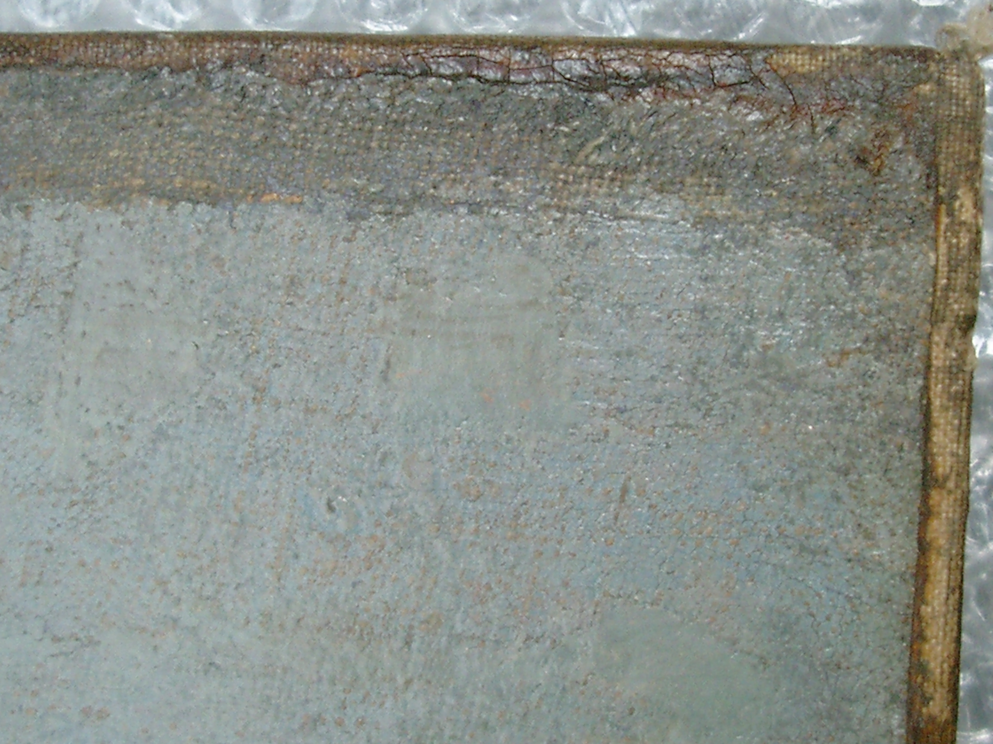
Original turnover edge with dark overpaint, showing the
coarser weave of the original canvas
Overpaint
Abraded original paint, pinkish spots are the tops of exposed canvas threads
Cut edge of original canvas
Lining canvas

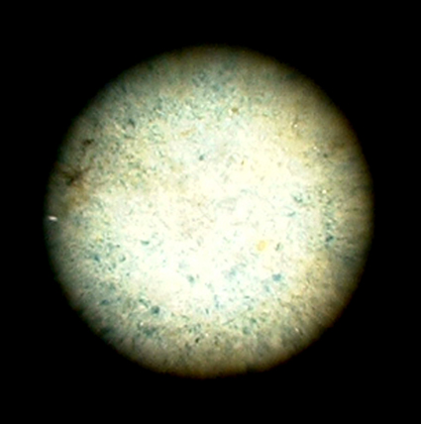
Detail of original sky, smalt, orpiment and white mixture, 43.75 x magnification.
Orpiment
Smalt

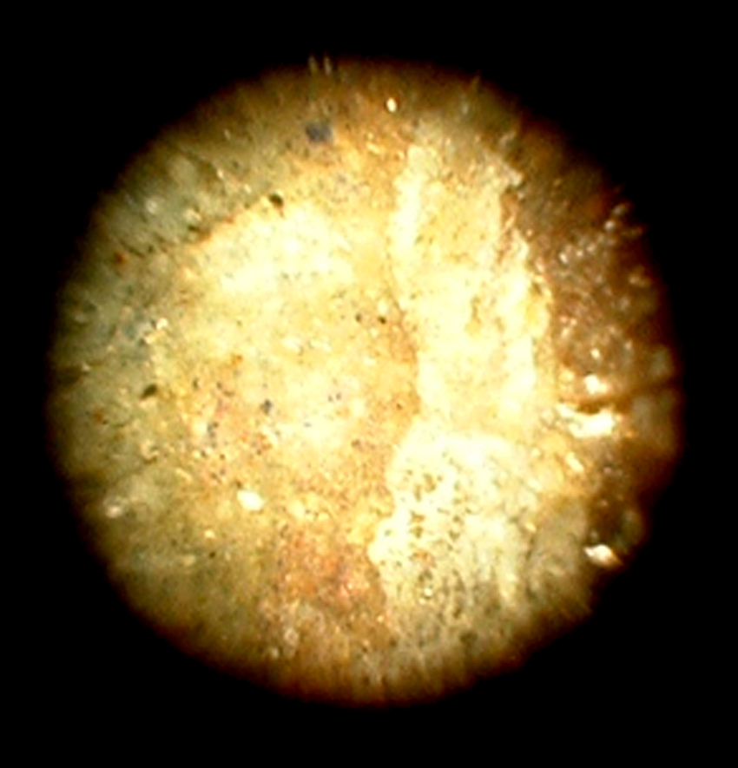
Detail of sky, top LHS, 43.75 x magnification.
Coarse overpaint with red and ultramarine type blue particles
Smalt and white original paint
Smooth overpaint with no visible pigments
Prussian blue or ultramarine glaze on top of original paint

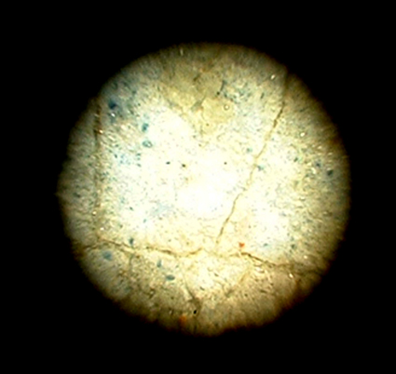
River, 43.75 x magnification.
Orpiment
Smalt
Earth pigment
Prussian blue or ultramarine blue glaze

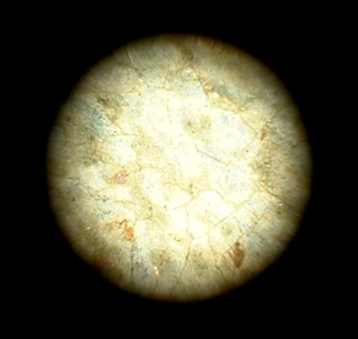
Detail of abraded paint in the river, 43.75 x magnification
Very pale, abraded original paint, almost white with few pigments visible.
Prussian blue or ultramarine glaze and discoloured varnish residues, also abraded over canvas tops
Exposed canvas threads

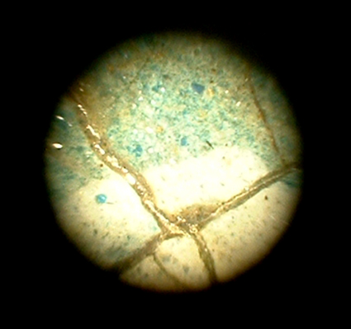
Water in the shadow of the bridge, 43.75 x magnification

Orpiment
Smalt
Transparent particles, possibly faded smalt
Prussian blue or ultramarine glaze

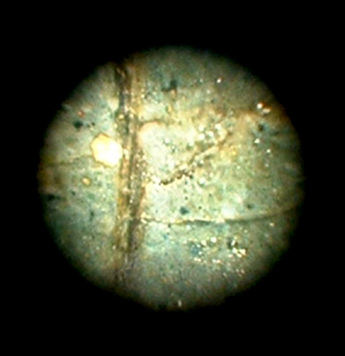
Bridge, 43.75 x magnification, visually appears pale brown/grey:
Transparent particles, possibly faded smalt
Blue/green verditer
Smalt
Orpiment

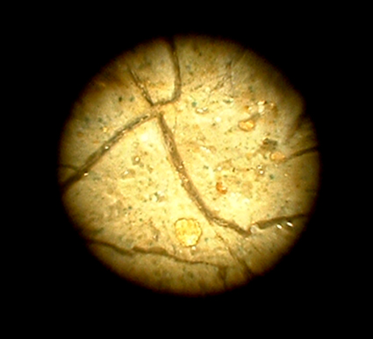
Town, 43.75 x magnification
Prussian blue or ultramarine glaze particles

Orange particle, possibly earth pigment
Orpiment
Transparent particles, possibly faded smalt

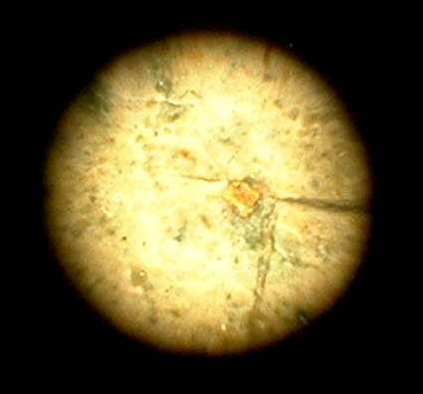
Tower, 2nd left from RHS of town, 43.75 x magnification
Smalt
Orpiment
Transparent particles, possibly faded smalt

CRACK TYPES: All over craquelure, with finer networks in the dark shadows, particularly the browns. The surface of the painting is rather broken and cracked with strong texture from weave emphasis in the original canvas.
FLAKING: None apparent.
LOSSES: Old tiny losses, unfilled and unretouched, especially in the dark shadows where cracks are more prominent. The paint is very topped and abraded.

OVERPAINT: Extensively overpainted, both under and over the varnish. In the sky, a band of blue paint at the top appears to be overpaint, possibly applied to cover the exposed canvas. Although a large amount of the surface is overpainted, the sky is not completely covered, as with some of the other paintings. Therefore, there are some areas where samples of original paint could be taken, and the original paint surface examined, e.g. top right corner, c.45mm down from top, c.45mm in from right.
Some of the retouchings have been filled first, while others have not.
BLOOMED OR BLANCHED: Unchanged from 1996.
CONDITION: Fair. Lots of lumps visible in the paint layer, from slubs in the canvas, weave emphasis and brittle cracks in the paint film. Appears stable.

VARNISH:
DISCOLOURED: Not significantly
DISFIGURING: See PATCHY
PATCHY: The broken, cracked, surface texture of the painting and the noticeable canvas weave texture from weave emphases contrasting with shiny, reflective areas makes the painting difficult to read.
MOULD: None apparent.
BLOOMED OR BLANCHED: None apparent.
SURFACE DIRT: Significant surface dirt deposit.

Rachel Howells
Painting conservator
28.05.08

